This non-paper is Poland’s contribution to the current intensive discussion on how to revive investment, growth and jobs in Europe. It outlines in more detail the proposal presented and discussed by the Ministers during September’s informal ECOFIN Council in Milan. It is also a contribution to the proceedings of the “Task Force on Developing Investment Project Pipeline in the EU” under the co-chairmanship of the European Commission and the European Investment Bank. The Task Force was established to lay the analytical foundations for concrete pro-investment and pro-growth strategies to be agreed by ECOFIN Council in December.

Disappointing growth performance
Six years since the start of the financial crisis, European GDP is still well below its pre-crisis level and around 10% below the level consistent with trend growth prior to the crisis. Unemployment and the negative output gap are at record-high levels and Europe is on the verge of deflation. Moderate recovery, which gave Europe so much hope, has recently stalled. Without concerted and decisive actions at both national and European levels, Europe faces the risk of secular stagnation in the form of permanently depressed demand and meagre long term growth rates. If the current slow growth continues, the EU economy will be almost 16% below its potential in 2019 (Figure 1).
Figure 1. Losing ground after the crisis.
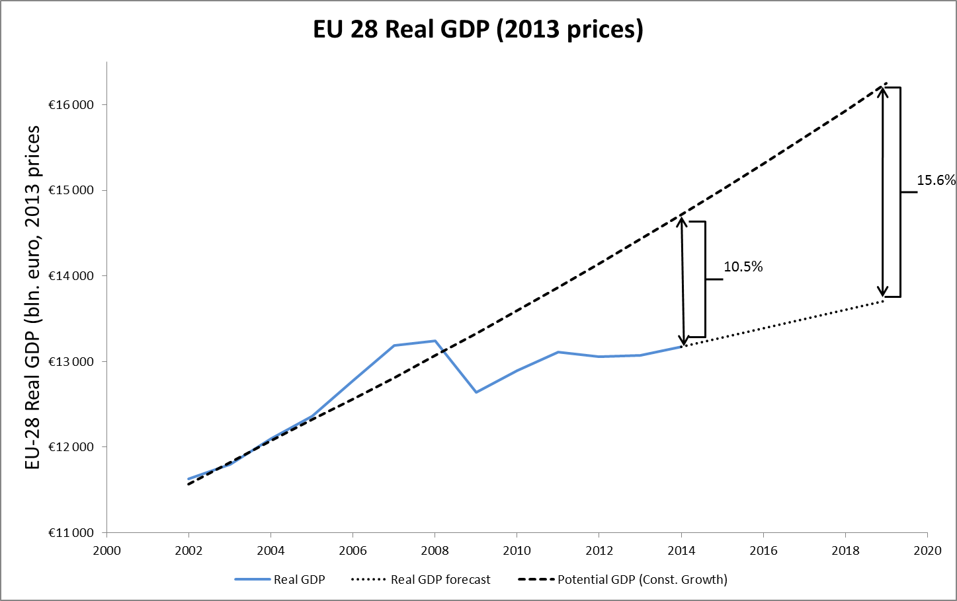
Europe needs prompt and concerted action
Europe’s road to recovery requires determination and the courage to take difficult decisions. The monetary, fiscal and structural actions undertaken so far have been insufficient to address Europe’s unfolding gloomy scenario and to stimulate long term growth. Efficient and effective national fiscal consolidation strategies within the parameters of the Stability and Growth Pact (SGP) would provide greater growth momentum and bolster trust in the economic future of Europe. Further structural reforms are essential to promote flexibility and increase long-term growth. Though indispensable, these measures will not be sufficient to overcome the fundamental problem holding back the European economy - depressed investment demand.
European public investment scheme to mobilize private capital
Currently, despite near-zero interest rates, the propensity of the private sector to invest is weak, particularly in areas involving higher risk and longer-term rates of return. An ambitious structural reform agenda should strengthen this propensity, thought an additional investment impulse from the public sector is necessary.
Such an impulse should take a form of an ambitious, pan-European investment programme, kick-started by a public capital contribution and leveraged by tapping private savings which are currently idling in financial markets. To overcome existing constraints on national fiscal policies, the EU-wide investment scheme would be set up at the Community level, specifically in the form of a European Fund for Investment (EFI). Such a financing formula would provide a strong pro-growth stimulus in full compliance with the SGP rules, and with very limited impact on the fiscal positions of Member States.
Based on conservative assumptions about the size of the current output gap and fiscal multipliers, closing the output gap in the medium term requires investment spending of around 5.5% of European Union GDP or 700 billion euros. This amount has been used as the basis for the current proposal. The overall size of the initiative would need to be reviewed based on forthcoming findings of the Task Force on the availability of good investment projects across Europe.
Large, pan-European investment projects to be a target
The investment boost would be targeted at achieving the Europe 2020 strategy goals and other EU pro-growth policies, by directing resources towards large-scale, economically viable projects, mainly in energy, transportation and ICT. Such projects do more than add to the economy’s capital stock and mobilize idle saving: they have long been defined as priority areas for long-term sustainable growth in Europe. These investment projects would contribute to the “energy union” (energy interconnectedness, independence and security), reduction of carbon emissions and other pollution, strengthening territorial cohesion, promotion of trade, investment and mobility among Member States, and shifting Europe towards digital union and a knowledge-based model of growth.
Supporting role of the EFI to SMEs’ financing
Part of the EFI’s funds could be invested in revolving instruments such as venture capital, loan or guarantee funds. Thus the EFI could provide equity contribution to financial instruments to directly support access to investment capital by SMEs and start-ups.

Structural reforms to underpin the scheme
Creating a growth-friendly environment requires structural reforms in the long term. EFI’s involvement in a project could be made conditional on commitment of a host Member State to such reform. Such conditionality could be modelled on that currently attaching to international financial institutions and mechanisms already applied by the EU, such as Country Specific Recommendations, issued annually to each Member State under the European Semester, could be a source of such commitments. For example, energy market liberalisation within a Member State could be made a prerequisite for EFI investment in this sector.
Similarly, specific projects could target improvement of structural features of the EU economy. For example, investment in cross-border energy interconnectedness would help to achieve the EU goals of energy union and a further deepening of the Single Market. Likewise, improvements in infrastructure would increase the supply side and positively influence long-term growth.
Institutional setup and financing
The precise institutional setup and governance rules of the EFI is crucial. The initial proposal is for the scheme to take the form of a new entity, set up in the framework of the EIB Group (currently consisting of the European Investment Bank and the European Investment Fund). This reflects a pragmatic consideration - we believe it is better to carefully tailor the new mechanism to the newly emerging needs, rather than introduce far reaching, politically controversial, legally difficult and operationally inefficient adjustment of the existing institutions, for example by changing the mandate and weakening the stabilising role of ESM or increasing the balance sheet and changing the risk profile of the EIB.
Thus the newly established Fund would operate as a special purpose vehicle, preferably within the EIB Group, to build on its expertise and know-how. Art. 352 of the Treaty on the functioning of the EU, linked with art. 308, provides a legal base for the EFI. On the basis of art. 28 of the EIB statute, the Governors may decide by unanimity to establish a dependent legal entity.
The financing of the EFI would resemble that for the European Stability Mechanism, with a gradual injection of paid-in capital by all EU Member States and guarantees in the form of remaining capital payable upon request. The paid-in capital would constitute a capital base, which would be then leveraged by issuing bonds in the international financial markets.
Impact on national budgets
According to the existing European rules, this form of financing would have only a limited impact on national budgets. EFI’s bond issuance in the financial markets would encumber only the Fund, not Member States. The paid-in capital would add to national deficits only in the form of debt servicing costs, and only if the paid-in contribution is covered by additional public debt. Taking Poland as an example, this would have an annual impact on the general government deficit of around 0.02% of GDP and on general government debt of around 0.93% of GDP (assuming total paid-in capital at 105 billion EUR and using the ESM contribution key). Table 1 presents illustrative data for all Member States.
Supplementary character of EFI funding
These additional resources available from the EFI would supplement − not replace or duplicate − EU budget financing, particularly the Cohesion Policy and the Connecting Europe Facility (CEF) funds, the crucial instruments of the investment policy of the EU budget. The EFI would leverage scant public resources by mobilizing private savings, and fill the co-financing gap currently holding back projects. It would also help finance projects that - for various reasons - are not eligible for EU budgetary support. Its resources would not be directed to individual Member States in a pre-determined manner, for example based on per capita income (no ‘earmarking’), but would be targeted at undertakings according to specific conditionality rules.
The EFI would build upon the experience of the CEF. Though a programme of crucial importance, the CEF is unlikely to be decisively enlarged to meet the pressing needs for pan-European infrastructure investment, due to the lack of fiscal space within the EU budget. The key difference between the CEF and the EFI in this respect is that the CEF is dependent on the EU budget as it operates mainly through grants (only up to 10% of its budget may be leveraged through the financial instruments); meanwhile, the EFI, by investing in equity, can finance itself from private saving via financial markets.
The EFI would also provide initial funding and hence boost the scale of financial instruments improving access to finance for SMEs and startups, such as joint risk-sharing financial instruments between the European Commission and the EIB Group.
Focus on equity rather than debt instruments
The EFI would complement the operations of the European Investment Bank, which supports investment projects across Europe mainly through lending. In contrast, the EFI would be, providing equity and quasi-equity instruments. Equity investment would overcome the challenge of low demand for loans caused by the ongoing deleveraging process in both the public and private sectors.
Direct participation of the EFI would target areas of untapped development potential where risk is relatively higher. It would attract private investors, who currently tend to consider large-scale infrastructure projects too risky in terms of future demand, regulatory environment and profitability. Involvement of the EFI would make such projects more “bankable”. It would also help to overcome the problem of funding the construction phase of infrastructure projects, which seems to be too risky for most institutional long-term investors.
Finally, through its equity involvement (in the projects or in other financial instruments), the EFI would compensate for the limited risk exposure capacity of European banks, whose balance sheet have been under pressure in the aftermath of the crisis and subsequent regulatory changes. This would improve access to financing both for large, pan-European infrastructure projects and for SMEs/start-ups.
Through its direct investment allocations, the EFI would temporarily become an owner or co-owner of the assets created through these investments. It would need to generate revenue streams sufficient to service its debt in the short-to-medium term (for example through user, availability or leasing fees) and would be expected to transfer ownership by privatization or nationalization (for critical infrastructure) at later stages in order to repay its debt. The approach would apply project structures similar to the BOOT (build-own-operate-transfer) and BLT (build-lease-transfer) structures frequently used in infrastructure projects. However, under present economic conditions, the EFI should be prepared for a prolonged ownership of the assets it acquires.
Diversification of EFI’s investment portfolio through its equity involvement into other financial instruments could diversify risks and ensure additional profits for the Fund.
Involvement of all Member States is necessary
While the EFI is mainly dedicated to large-scale pan-European projects, absence of any Member State in the programme could undermine implementation of some projects of key importance for the whole EU. Therefore, the scheme should be set up by and for all EU Member States – unlike the European Stability Mechanism, which was established only by Euro Area countries. Moreover, all Member States would benefit directly or indirectly from the initiative, so all of them should make a financial contribution to the EFI’s capital.
Concluding remarks
Now is the right time to act. Europe should boost public investment by taking advantage of historically low interest rates and potentially large multipliers generated by investment spending in a depressed economy.
In the current circumstances, stimulating short-term growth rates and increasing long-term ones by debt-financed investment is also fiscally prudent. As confirmed by the latest analysis of the International Monetary Fund (among others), such investment would actually reduce public indebtedness.
We can sustainably meet our growth aspirations only within a strong and growing Europe. The responsibility for ending the lost decade and avoiding a lost generation weighs on all EU Member States. The European Fund for Investment is the right means to this end.
The forthcoming findings of the Task Force on critical investment gaps and economically valuable projects should enable European policy-makers to make bold and well-informed strategic decisions sooner rather than later. Given the current economic weakness of the European economy and the dire forecasts for its future, doing “too little” represents a greater danger than doing “too much”.

 | ESM contribution key¹ (including temporary corrections)  (%) | Investment capacity  (bn Euro) | Paid-in capital  (bn Euro) | Total subscribed capital  (bn Euro) | GDP  (bn Euro) | 10Y Bond yield  (denominated in euro)²  (%) | Impact of paid-in capital on deficit  (% of GDP) | Public debt  2013  (bn Euro) | Impact of paid-in capital on public debt  (% of GDP)
 | 1 | 2 | 3 | 4 | 5 | 6 | 7 | 8 | 9
Formula |  |  |  |  |  |  | 3 * 6 / 5 |  | 3 / 5
European Union (28 countries) | 100 | 700 | 105 | 920 | 13 068,6 |  |  | 11 386,0
Austria | 2,1025 | 14,72 | 2,21 | 19,34 | 313,1 | 1,03 | 0,01 | 233,3 | 0,71
Belgium | 2,6537 | 18,58 | 2,79 | 24,41 | 382,7 | 1,14 | 0,01 | 387,2 | 0,73
Bulgaria | 0,4368 | 3,06 | 0,46 | 4,02 | 39,9 | 2,93 | 0,03 | 7 532,9 | 1,15
Croatia | 0,3853 | 2,70 | 0,40 | 3,54 | 43,1 | 2,50 | 0,02 | 28,9 | 0,94
Cyprus | 0,1231 | 0,86 | 0,13 | 1,13 | 16,5 | 8,81 | 0,07 | 18,4 | 0,78
Czech Republic | 1,1566 | 8,10 | 1,21 | 10,64 | 149,5 | 1,08 | 0,01 | 65,2 | 0,81
Denmark | 1,5929 | 11,15 | 1,67 | 14,65 | 248,9 | 2,50 | 0,02 | 110,8 | 0,67
Estonia | 0,1516 | 1,06 | 0,16 | 1,39 | 18,6 | 2,50 | 0,02 | 1,8 | 0,86
Finland | 1,3456 | 9,42 | 1,41 | 12,38 | 193,4 | 0,95 | 0,01 | 110,2 | 0,73
France | 15,1861 | 106,30 | 15,95 | 139,71 | 2 059,9 | 1,20 | 0,01 | 1 925,3 | 0,77
Germany | 19,2753 | 134,93 | 20,24 | 177,33 | 2 737,6 | 0,85 | 0,01 | 2 147,0 | 0,74
Greece | 1,5081 | 10,56 | 1,58 | 13,87 | 182,1 | 8,07 | 0,07 | 318,7 | 0,87
Hungary | 0,8894 | 6,23 | 0,93 | 8,18 | 97,9 | 2,35 | 0,02 | 77,7 | 0,95
Ireland | 1,2431 | 8,70 | 1,31 | 11,44 | 164,0 | 1,70 | 0,01 | 202,9 | 0,80
Italy | 13,185 | 92,30 | 13,84 | 121,30 | 1 560,0 | 2,38 | 0,02 | 2 069,2 | 0,89
Latvia | 0,2073 | 1,45 | 0,22 | 1,91 | 23,4 | 2,00 | 0,02 | 8,9 | 0,93
Lithuania | 0,2974 | 2,08 | 0,31 | 2,74 | 34,6 | 1,83 | 0,02 | 13,6 | 0,90
Luxembourg | 0,2174 | 1,52 | 0,23 | 2,00 | 45,5 | 2,50 | 0,01 | 10,5 | 0,50
Malta | 0,0553 | 0,39 | 0,06 | 0,51 | 7,3 | 2,15 | 0,02 | 5,2 | 0,80
Netherlands | 4,2878 | 30,01 | 4,50 | 39,45 | 602,7 | 0,97 | 0,01 | 443,0 | 0,75
Poland | 3,4662 | 24,26 | 3,64 | 31,89 | 389,7 | 1,72 | 0,02 | 224,5 | 0,93
Portugal | 1,3561 | 9,49 | 1,42 | 12,48 | 165,7 | 3,23 | 0,03 | 213,6 | 0,86
Romania | 1,4537 | 10,18 | 1,53 | 13,37 | 142,2 | 2,89 | 0,03 | 54,0 | 1,07
Slovakia | 0,5966 | 4,18 | 0,63 | 5,49 | 72,1 | 1,48 | 0,01 | 40,0 | 0,87
Slovenia | 0,2822 | 1,98 | 0,30 | 2,60 | 35,3 | 2,65 | 0,02 | 25,3 | 0,84
Spain | 9,4687 | 66,28 | 9,94 | 87,11 | 1 023,0 | 2,16 | 0,02 | 960,7 | 0,97
Sweden | 2,4343 | 17,04 | 2,56 | 22,40 | 420,8 | 0,21 | 0,00 | 166,5 | 0,61
United Kingdom | 14,6453 | 102,52 | 15,38 | 134,74 | 1 899,1 | 2,26 | 0,02 | 1 752,4 | 0,81
¹ For BG, CZ, EE, EL, HR, CY, LV, LT, HU, MT, PL, RO, SI, SK correction of the contribution key is applied using the same formula as established under the ESM Treaty. Figures for countries not benefiting from correction key are adjusted proportionally.
² Numbers based on Reuters data base. Data for UK represents 10Y Bond yield denominated in pounds. Due to lack of data figures for DK, HR and LU are assumed at level of 2,50.

This legal base was used for establishment of the European Investment Fund within the EIB Group and could apply to EFI.
Including Eurostat decision of 31 January 2013 on deficit and debt statistical classification of the ESM.
We base on an assumption that the EFI’s paid-in capital to its investment capacity ratio is 15%, similarly to the ESM’s paid-in capital to its lending capacity ratio. Assuming the EFI’s investment potential at 700 bn euro, its paid-in capital would amount to 105 bn euro.

